Banyjima native title - David Stock family and Yandicoogina
Yandiguji married to Tharu: In Appendix D, ‘Descendants of Yandiguji and Tharu’, Palmer describes a woman named ‘Yandiguji’ as David Stock’s grandmother and ‘Tharu’ as her spouse. According to my records, Mark Chambers (2005) also records the name ‘Tharu’, but as the wife of apical ancestor, ‘Yandikutji’.

Paragraph 799 discusses the man, Kip, who Palmer claims ‘was married to Ivy Swan’. Evidence cited in the previous section of this report, indicates that the marriage was arranged by a government official and the station manager and lasted less than a year. Palmer records that Felix [Bill] Dershaw had seven children. The genealogy records their mother as Betty Indich. My impression from David Stock was that Kip was probably not a blood relative of Yandiguji, although a classificatory ‘brother’. Yandiguji is said to have been a Banyjima Man. Kip’s daughter, Stella Kip, married Poonda Bob, a Nyiyaparli man and their son was Johnny Poonda.

Palmer (Paragraph 796) states Tharu was married to a woman called Yandiguji’. Paragraph 797 Palmer writes that David Stock told him that ‘his own fm was called Yandiguji and it is her name that he now carries’. The report is puzzling because I record David Stock’s FF as ‘Yandikutji’, and not his FM. My information also comes from David Stock as I will explain in the following section. Palmer (Paragraph 798) also claims that David Stock’s father Woodstock Paddy was a Banyjima man. However, much of Palmer’s information appears to have come from claimants other than David Stock (Paragraph 798).

As Palmer notes in footnote 821 to Paragraph 798, a report by Clark and Smith (1982), cited below, suggests that David Stock’s grandmother was buried near Yandicoogina Creek. The report also states that David Stock ‘had inherited ownership of rights [to Yandicoogina Creek area] with his sister [Dollican, (dec. 1993)]’. Research by Bill Day with David Stock in about 2004 records that David’s grandfather was named ‘Yandikutji’ and it is through his grandfather that he inherited his name. This would be most likely, through Aboriginal tradition. However, David’s Banyjima rights to the Yandicoogina area could come through both his grandparents, including his grandmother’s burial place near Yandicoogina Creek

David’s father, Paddy Stock, alias ‘Mardathada’, also known as ‘Woodstock Paddy’, married a Nyiyaparli woman, Walaba, and their son, David Stock, grew up on Roy Hill station. David stock told me in 2005 that she was born on Poonda Station. He said, ‘That’s where my mother’s mob, my uncles used to stay. Up from Marillana on the flat, the floodout near Coondina Pool between Roy Hill and Marillana (pers com)’ David Stock therefore inherited rights as a Nyiyaparli man through his mother and her connection to Mount Newman, an important site on a Dreaming track described by Louis Warren in 1998 and 2000 (below). None of the above information appears to contradict the observations by Clark and Smith cited below.

Kim Barber records ‘Dardana’ as Yandikutji’s wife, which is the same name David Stock gave me. David Stock’s comment regarding his grandfather ‘Yandikutji’ was, ‘My father told me about him’. As stated above, Mark Chambers (2005) also recorded ‘Yandikutji’ as the male apical ancestor who died ‘before 1910’; however, in 2005 Chambers recorded ‘Tharu’ as Yandikutji’s wife.

It is not known who Palmer’s ‘other claimants’ were. However, David Stock was the source of the genealogical data recorded by Bill Day that ‘Dardana’ was the wife of David’s grandfather, ‘Yandikutji’. Therefore it would be Dardana’s grave that is referred to by Clarke and Smith (1982:8). David’s comments to Bill Day were, ‘[Dardana] died before I was born’. Kim Barber in his 1996 genealogy records her death as 1915. As stated, Chambers records her name as ‘Tharu’.

In summary, earlier reports refer to the burial of David Stock’s grandmother near Yandicoogina Creek and that David Stock had inherited rights to the Yandicoogina area (and presumably the name); however, the reports do not say that the name or the rights were specifically inherited from the grandmother, although obviously there would be rights inherited through her burial place. David Stock told Bill Day that his grandfather was ‘Yandikutji’. This is also recorded by Kim Barber (1997) and Mark Chambers (2005). O’Connor (1996:23) noted:

Nyiaparli... (b) In the Hamersley Ranges, their boundary with the Pandjima was along the Weeli Wolli/Marillana/Yandicoogina Creek system (the tribal name of David Stock, a part-Nyiaparli man from Marble Bar, is ‘Yandicoogina’).

O’Connor (1996:7) notes: ‘The relevant Nyiaparli [sic] group was the Warrawandoo group, whose members included Mr David Stock’s mother, Mr Horace Parker’s mother and Mr Horace Nelson’s mother and father.’ According to Bill Day’s recorded genealogies, David Stock’s mother was named ‘Walapa or Yurawalypa’, a Nyiyaparli woman who is identified with Mt Newman. She was born on Poonda Station. In 2005 David Stock told me, ‘[My mother] got sick at Roy Hill and died at Millstream looking for a marban [Aboriginal doctor]’.

In a 2000 report, Louis Warren recorded information given to him regarding Mount Newman:

Mount Newman (Mirturamuna) Site identifier 17249
The following information on the site has been previously reported in Warren (1998:20-21). According to Mr Joshua Booth (a Manyjiljarra man who resides at Newman), Mt Newman is a mythological site named Mirturamuna. The site is part of a kangaroo Ancestor ‘Song Line’ or ‘Dreaming Track’ of possible Banyjima language group origin (he said it was a Banjima Wartil). To his knowledge the Kangaroo travelled from Mirturamuna to another site (P02051) at the Jimlebar turnoff (a large rock immediately adjacent the Newman to Nullagine road to the east of Newman). ...Mr Gordon Yuline also gave the name of Mount Newman as Mirturamuna, and confirmed the mythological association of the site to a kangaroo Ancestor that had travelled through to the Newman area from Banyjima country. Gordon also related that the Kangaroo Ancestor was injured and bleeding and that the red colour (iron ore) of the former Mount Whaleback represented the blood.

David Stock was initiated at ‘Pug Well’ (Pint@rli) within the Nyiyaparli native title claim at a bore adjoining the MIB claim. David has grandchildren descended from his marriage to Phyllis Spade, who is recorded as the daughter of Jemina Ingan and granddaughter of Sally Warbun. Through cognative descent her children therefore may choose to be either Nyiyaparli, Top or Bottom End Banyjima or Thudgari from Phyllis’s father, Jack Spade. To my knowledge they have not asserted any rights as Fortescue Banyjima or to membership of the MIB claim group.

Kip, recorded as Paddy Stock’s ‘brother’, was the father of Felix [Bill] Derschow and Stella Kip. As noted by Clark and Smith, Stella Kip claimed the same grandmother as David Stock. The descendants of Yandikutji therefore could include the descendants of Poonda Bob and Stella Kip and the descendants of Felix ‘Bill’ Derschow and Betty Indich. It is not known by the writer of this report if any of these descendants identify as Banyjima.

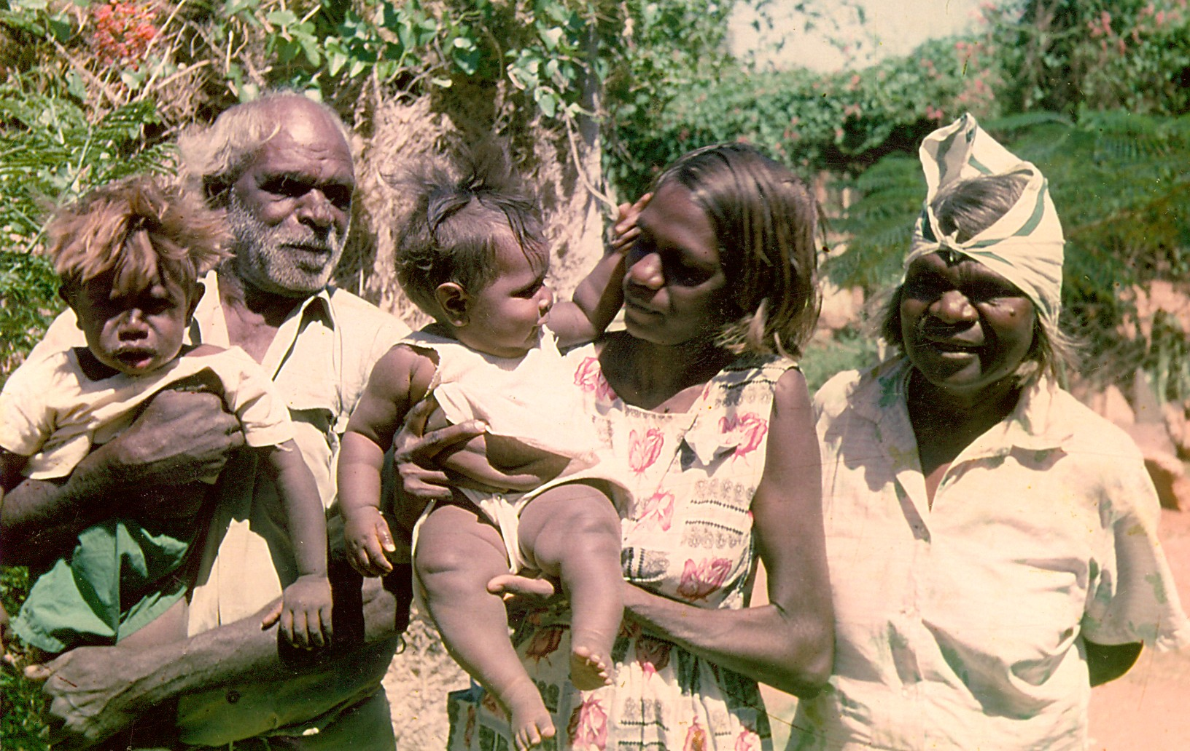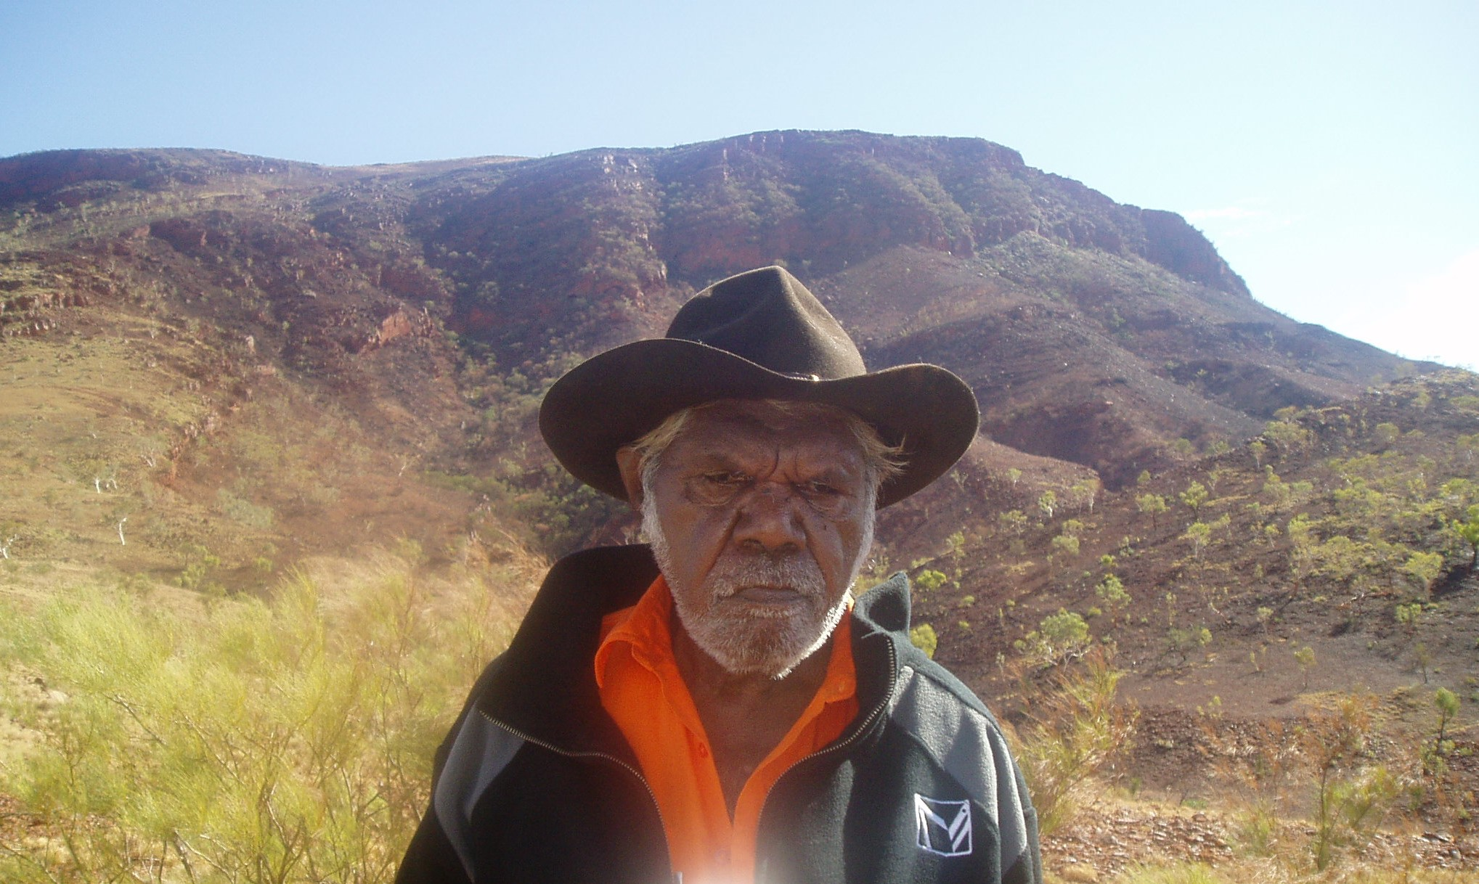
Left: Snake McKenna, Bonnie Tucker and Fannie Waliba with children.
Right: David Stock standing in front of his mother’s site, Mount Newman (Mirturamuna). See Warren (2000).

In addition, Bonnie Tucker claimed that there was a female named ‘Yandicoogina’ who was married to a man who ‘drowned in Nullagine’. ‘Yandicoogina’ in this case, is said to be the mother of Bonnie’s father, Snake McKenna. There is no confirmation of this information. The parents of Bonnie Tucker were Fannie Waniba and Snake McKenna (pictured below with Bonnie). Snake is variously recorded as a Palyku/Kartujarra/Wanman/Nyiyaparli man but appears to have migrated from the Western Desert. I consider it unlikely that Snake had a mother named ‘Yandicoogina’. In other words, I consider the information to be unreliable. If Bonnie’s paternal grandmother did bear the name, ‘Yandicoogina’, I consider that it was unlikely there was any connection to Yandicoogina Creek. However, Bonnie’s information may have added to the confusion over whether Yandikutji was male or female. Similarly, people have assumed the woman buried near Yandicoogina Creek was named ‘Yandicoogina’. As I have noted, it was her husband, David Stock’s grandfather who was named ‘Yandikutji’.

Clarke and Smith (1982:8) state:

At Marble Bar there was general consultation. The oldest man with extensive local knowledge was infirm. A younger man, David Stock, bore the name ‘Yandicoogina’, and has inherited ownership of rights with his sister [Dollican]. Their grandmother had been buried there. An older but active man, Poonda Bob, had been born at Poonda, raised at Roy Hill, and worked on surrounding stations including Marillana. He and Mundy Stevens were assigned to the initial survey. This included a visit to Marillana Station, Weeli Wolli Spring and the prominent peaks in the north and west of the survey area. Several sites were located, but further consultation was needed for the location of others, including the burial of the woman referred to above.

Clark and Smith (1982:9) continue:

The Panjima were consulted about the survey at Onslow. Herbert Parker and his brothers were regarded as the most appropriate informants. The survey area was Herbert’s grandfather’s country, and Herbert had been taken to the survey area as a child ...

Other Pandjima informants were consulted in April 1980 at Onslow including an old and infirm lady who had lived in the survey area as a child. Arrangements were made to proceed with the survey following a Bush Meeting. At the Bush Meeting, of which Herbert Parker is Chairman, some topical controversies about site protection, including Noonkanbah, were raised. The Aboriginal view was expressed that future conflicts would also be ruled in the developer’s favour, and that site surveys were ineffective, and might even attract developers’ attention to sites. Herbert Parker decided against further participation in surveys of Pandjima country. Marble Bar was visited to explain this development to the Niabali, who were, understandably, unwilling to proceed without the Pandjima.

On page10, Clark and Smith (1982) further note the extent of their consultation with traditional owners:

In October 1981 the survey area was re-visited with Poonda Bob and his wife Stella Kip, to whom the buried woman was a grandmother. We could not locate the burial, but defined the likely area in which it would lie. A visit to the area from Onslow with Herbert Parker and two younger men, his son Slim Parker and Trevor Hicks was also made... Herbert Parker confirmed the previous information about sites, and further defined the likely burial area. This was confirmed by his eldest brother in Onslow. Finally Marble Bar was re-visited to relay the results of the Pandjima visit to Poonda Bob and David Stock.

The conclusion from the above section discussing the descendants of Yandikutji is that Yandikutji was the grandfather of David Stock and that Yandikutji’s wife was named either Dardana or Tharu and is buried near Yandicoogina Creek. However, it should be noted that the genealogies used by Palmer (2010) and those recorded by Day have all either directly or indirectly incorporated information from the genealogies recorded by Kim Barber in 1996 for the original IBN native title claim. A subpoena was issued in 2011 to Gumala Aboriginal Corporation for Barber’s genealogies but no trace of the genealogies could be found. Differences in genealogies appear to come from information gathered between 2006 and 2010 during the preparation for a ‘One Banyjima’ native title claim.

See Adrian Day (2010:224-228) for an account of an incident involving Dollican Stock and Poonda Bob.

