The Larrakia elder, Dolly Gurinyi, died in 1973. In her lifetime, Dolly was known as a ceremonial leader amongst women in the Larrakia and neighbouring language groups. The linguist Mark Harvey acknowledges his debt to Dolly Gurinyi in his recordings of the Larrakia language held by the Australian Institute of Aboriginal and Torres Strait Islander Studies. Her photo as ‘Corporal Dolly’ appears on page 23 of ‘Aboriginal Darwin: a guide to exploring important sites of the past and present’ (T Bauman, 2006). Dolly was closely involved with the Kulaluk land claim and the land claim to Emery Point (see photographs below). Tibby Quall has consistently reminded the courts of the central role his great Aunty Dolly played in maintaining Larrakia laws, customs and language. After Dolly died, a sequence of events marginalised the Batcho family in the land claim process. Firstly, Topsy Secretary who had supported their inclusion withdrew from active involvement in the Kenbi claim. Judging from the Kenbi transcripts Topsy was disillusioned by the inclusion of many families in the wider Larrakia group that she had not previously identified as Larrakia, leading to her disputing the NLC genealogies in the hearings before Mr Justice Gray. Then following Topsy’s death before the completion of the native title claim, her descendants at Kulaluk were included in the wider Larrakia group on what we would suggest was bad advice from their point of view but understandable considering that the NLC was convinced that the wider Larrakia language group case was winnable. There does not appear to have been any explanation of how Dolly Gurinyi could be such an important figure in Larrakia and Danggalaba society while her nieces and nephews and their descendants were lumped with the wider ‘post-modern’ and ‘revived’ Larrakia group, many of whom, it could be suggested, had lost their connection to land under the requirements of the Native Title Act. The transcript reveals a growing frustration by members of all branches of the Danggalaba clan with the representation by the NLC, combined with evidence of fears of public intimidation leading to some like the Thompsons taking no part in the claims. Once this complicated net had been cast, there was little chance of a focussed Danggalaba clan case being presented. Only now that the air has cleared somewhat, allowing for a fresh start, can their case be properly presented.
Dr Bill Day,
Consulting Anthropologist
November 2010
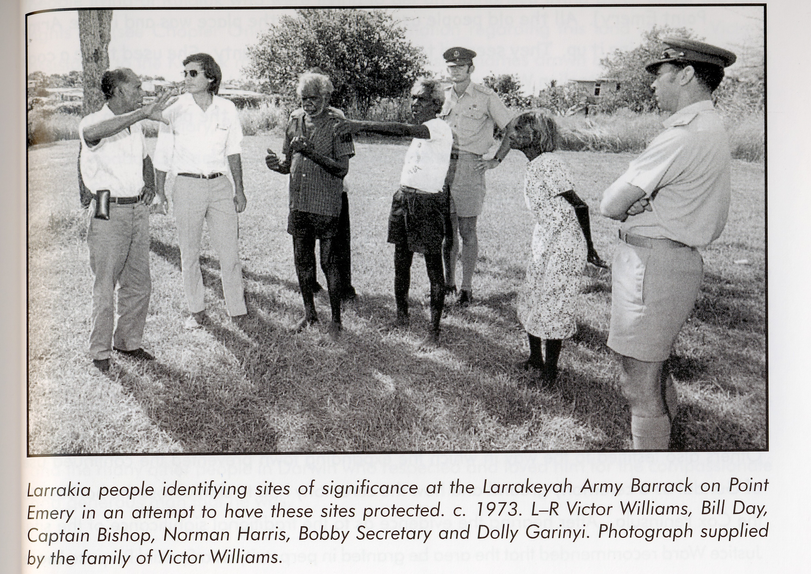

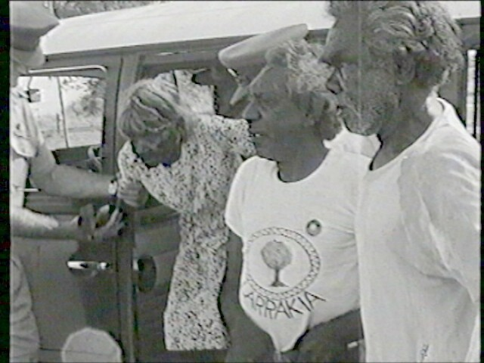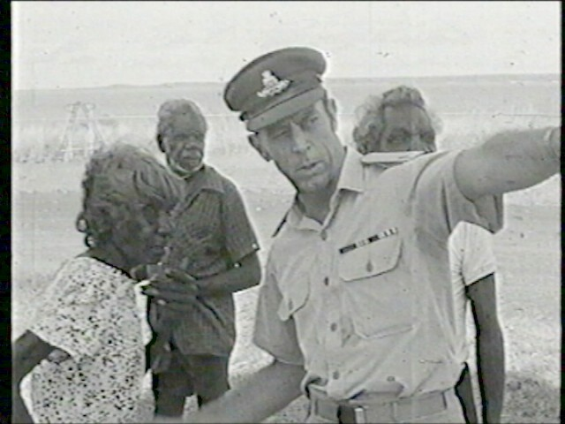
Above, left: Dolly Gurinyi, Bobby Secretary and Captain Bishop visiting Larrakeyah Army Barracks in Darwin to inspect a sacred site at Emery Point in May 1973.
Above, right: An army officer questions Dolly Gurinyi about the boundaries of the sacred site at Emery Point with elders Norman Barral Harris and Bobby Secretary (behind).

