Q: Was this woman "the last of the Larrakias" as reported in the newspaper at the time?
A: After the tragic death of Kathleen Secretary a funeral notice was placed in the NT News on 5th February 1986 by the Gwalwa Daraniki Association stating that a funeral will be held “at the traditional burial ground at Kulaluk opposite Totem Road on the sea side of Dick Ward Drive on February 11 at 10am.”
A death notice in the same paper stated that the deceased was “accidentally killed February 1st, 1986. Beloved mother of Lynnette, Christopher, Helen, Anna, Jaqueline and Kathy. Much loved daughter of Samuel [Yurugudamin] and Topsy [Secretary].”
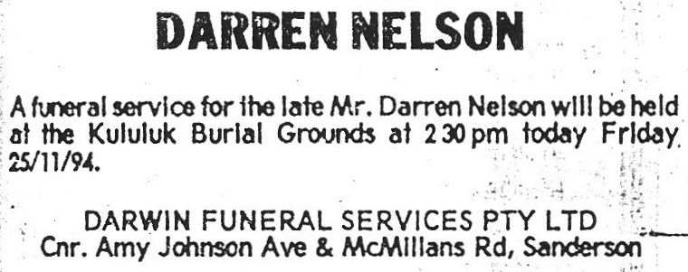
Two months later, “The Midweek Territorian” published a one-page article headed “THE LAST OF THE LARRAKIA” (April 16, 1986, page 2). The article by Margo Towie (attached in part) claimed “...the once proud and powerful people have been reduced to five direct descendants.” However, Kathleen’s mother, Topsy Secretary, drew up a Larrakia family tree in 1973 that showed over 110 Larrakia people. Since then the tribe has greatly expanded and the Larrakia Nation Aboriginal Corporation lists over 1,600 members. Importantly, those who claim that Kathleen's third youngest child, Helen, is the traditional owner of the 301ha Kulaluk lease are supporting the fiction that the Larrakia tribe are “reduced to five direct descendants” of the one family, or two families, if we take into account the Cox Peninsula claimants across the harbor.
Q: Who was Chris Shields?
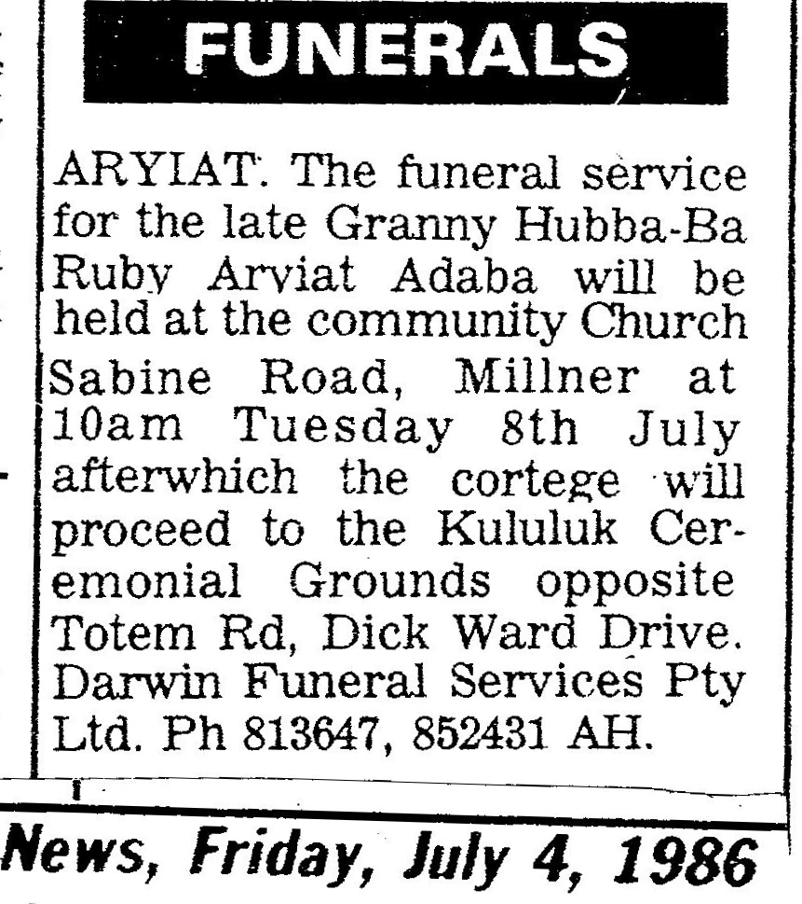
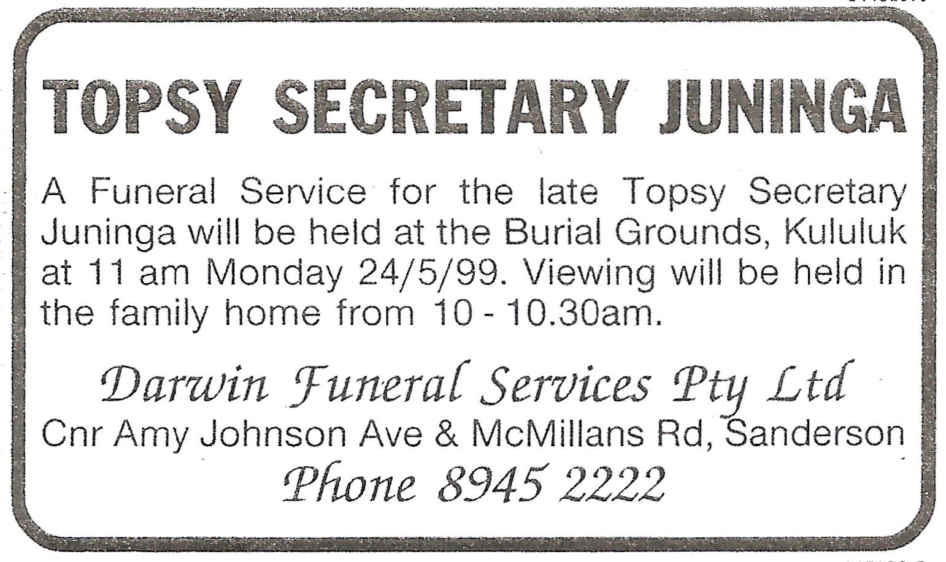
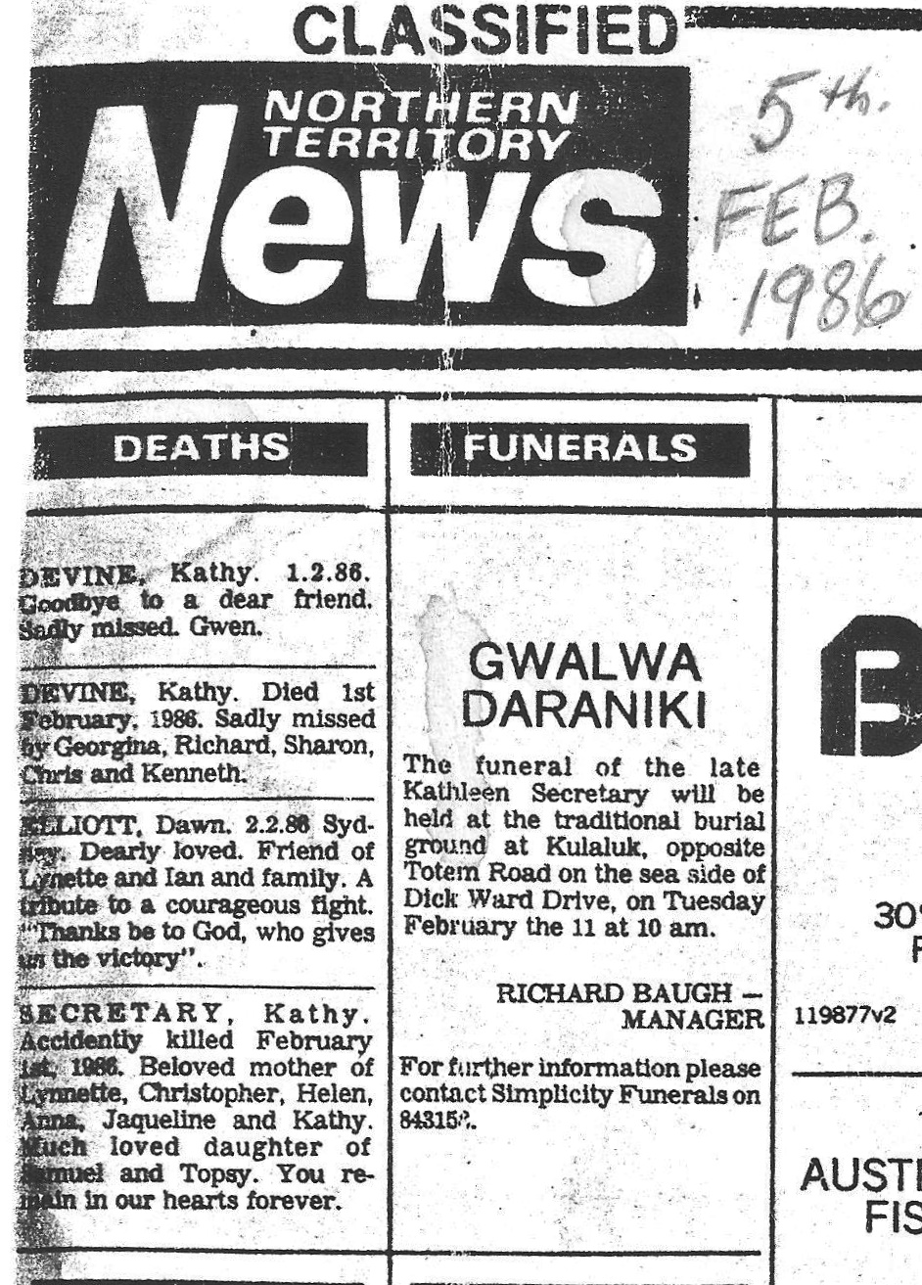
A: He was the eldest son of Kathleen Secretary. Lynette Shields is the eldest child. Their father was Christopher Shields senior (Dec). Sadly he died suddenly at an early age The late Rikki Shields was their uncle. Rikki was a strong defender of saving the Kulaluk land and lived for many years in UK where he campaigned for the return of Aboriginal bones from European museums.
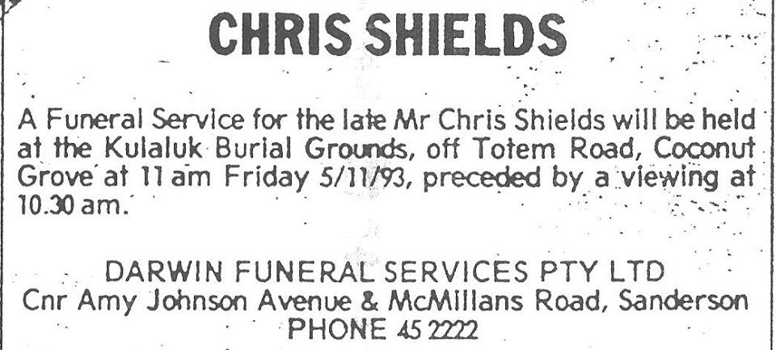

Q: Who was Darren Nelson?
A: This non Aboriginal man was Helen Secretary's partner for ten years. During their time together he terrorised his partner so badly that she shot and killed him while he was sleeping at their house in the Kulaluk community. The trial transcript says Nelson "used to come into the office and tell us what to do". This was a crucial time for the lease when an agreement was being negotiated with McDonalds for a one hundred year sublease and Citiland Jape began talks. At Kulaluk non Aboriginal partners have always dominated the lease holding association. And yet this man was given full funeral rites in the sacred ground!

