“JUSTICE DENIED”
THE TRIAL OF
GRAHAM X

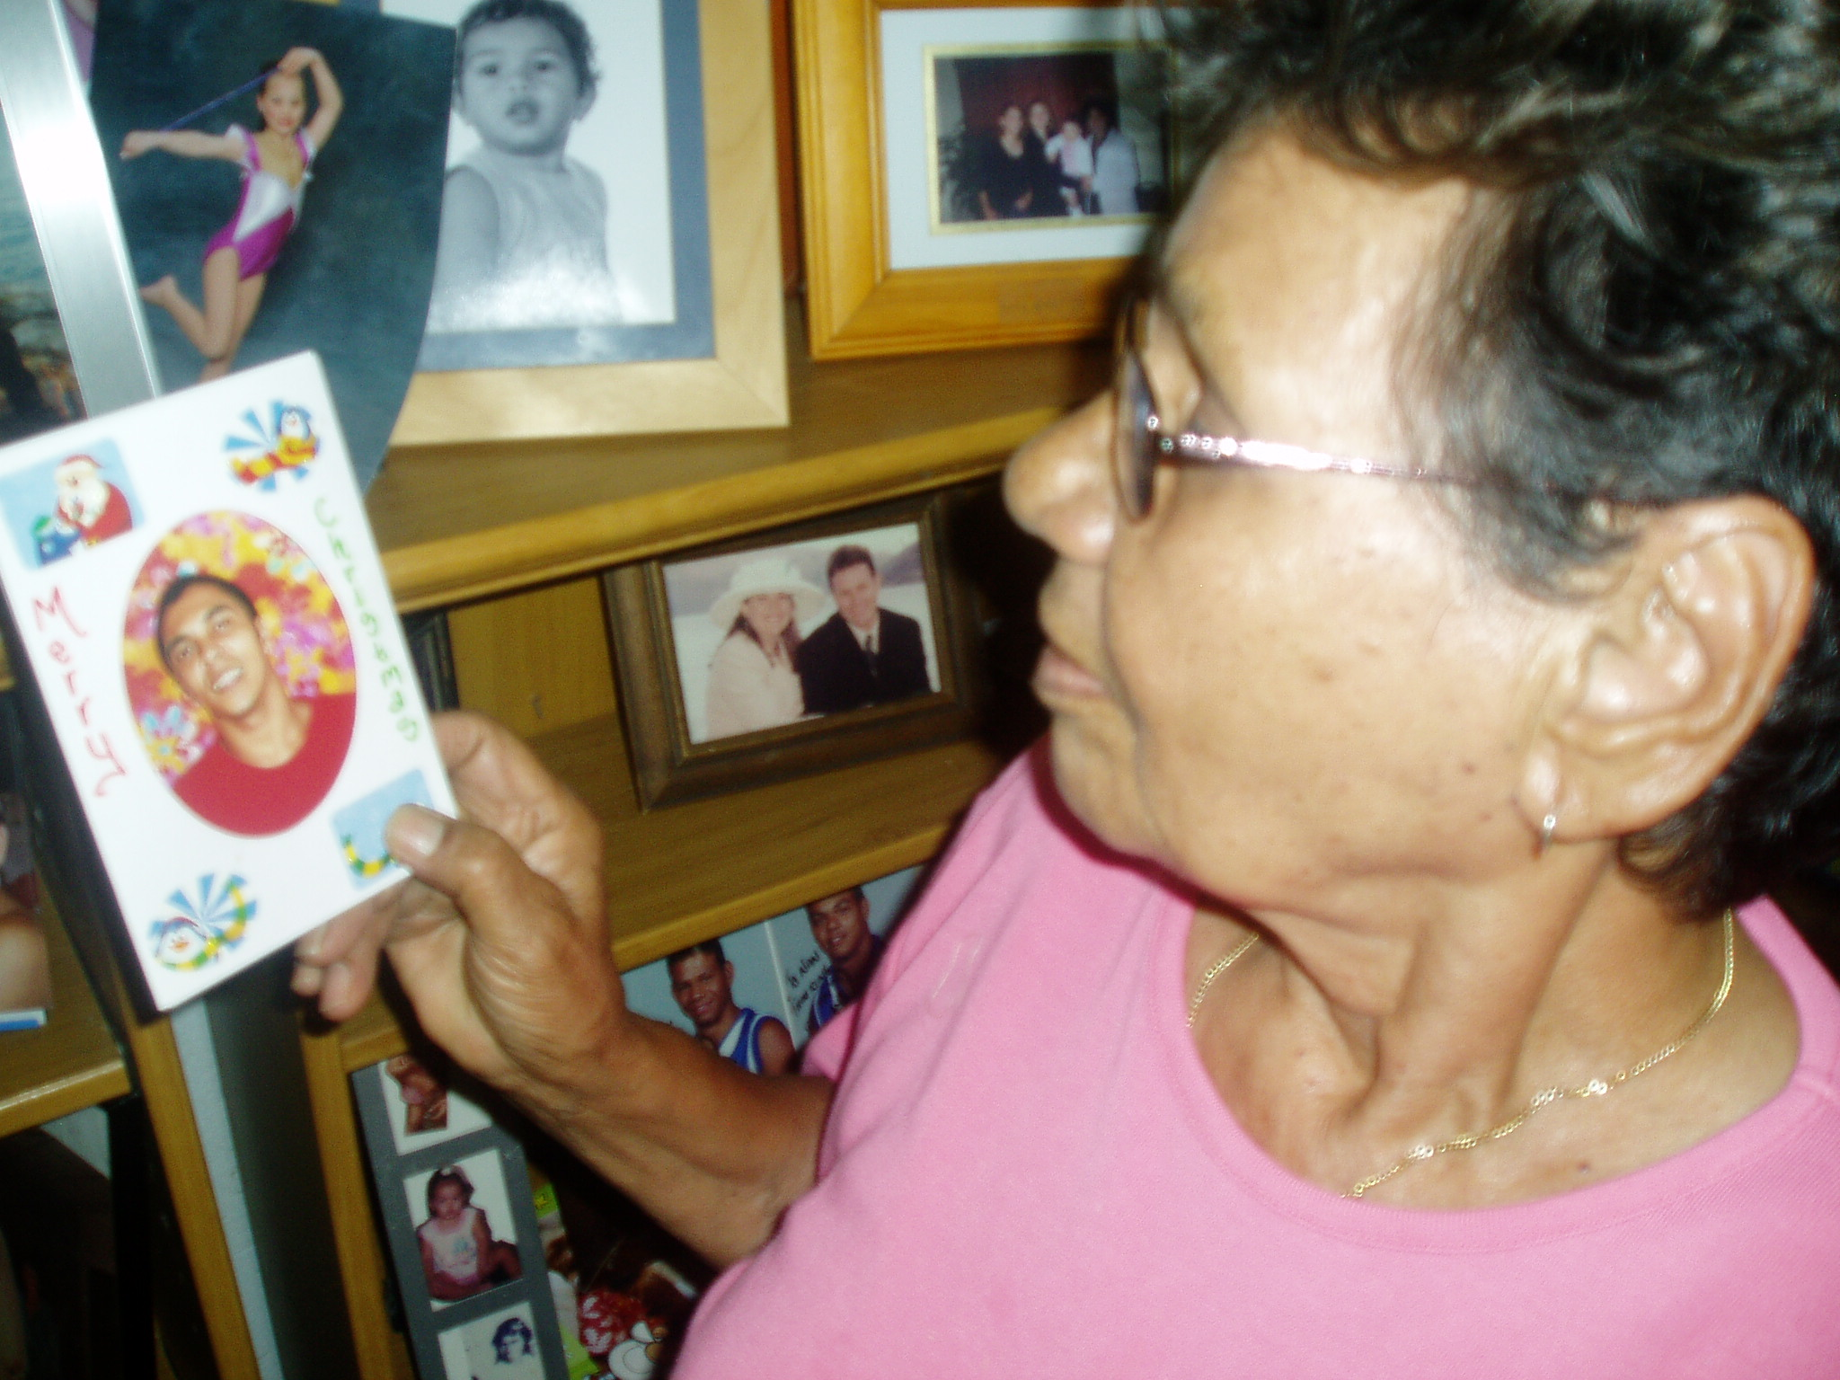
Above: Graham X's grandmother at home in the Northern Territory

An Aboriginal boy sentenced to seven years
in Darwin's Berrimah Prison

SENTENCING

PRECEDENTS

How the judge got it wrong

CASE NOTES

written by
W. B. Day PhD
taken from transcripts
and witnesses

JAIL
LETTERS
TO
GRAHAM X

DARWIN'S
NOTORIOUS
BERRIMAH
PRISON

Graham X's ordeal
2006 - 2015
Introduction
Graham X has done his time – seven long years in the overcrowded Berrimah Prison on the outskirts of Darwin, capital of the Northern Territory of Australia. He maintained his innocence throughout his sentence, and as a result was not released on parole, serving the full sentence handed down in March 2007 by Chief Justice Brian Martin.

Before sentencing, the Chief Justice was surprised to hear that the only time Graham X had been in detention was since the guilty verdict in November 2006. A supposed rapist had been free to live freely in the Darwin suburbs since May, 2003. In those 3½ years the 15-year-old boy had grown to a to a youth approaching 19, with a steady girlfriend, soon to give birth to their child.

The delay in trying Graham X was significant in other ways. In 2005 the Chief Justice had become embroiled in a media controversy after sentencing an Aboriginal man to one month imprisonment for the rape of a 14-year-old girl. The sentence was appealed and the judge was condemned in the national media for his leniency.

So it was, that unaware of the political storm, Graham X stood in the dock before a judge needing to prove his credentials. In this racially-charged environment, as an Aboriginal youth charged with sexual offences against a white girl, and without a representative jury, the scales were weighed against the accused.

The background to the charges against Graham X, the evidence produced at the trial and the media storm in which the trial occurred is analysed in detail in the following pages. Court precedents are discussed which illustrate the injustice of the sentence given to Graham X. Copies of letters to the prisoner and other correspondence are also reproduced, along with pages of revealing case notes.

As can be imagined, the experience of incarceration, much of the time in isolation as a result of maintaining his innocence, has ill-prepared Graham for life on the outside. Burdened by his criminal record and disadvantaged by the ongoing effects of his traumatic experiences, Graham X's case remains, A CASE OF JUSTICE DENIED.

Note: as the reader will gather, Graham X is a pseudonym for the accused boy, used in documents to protect his identity on the internet. However, the full name of Graham X appears throughout this file.

