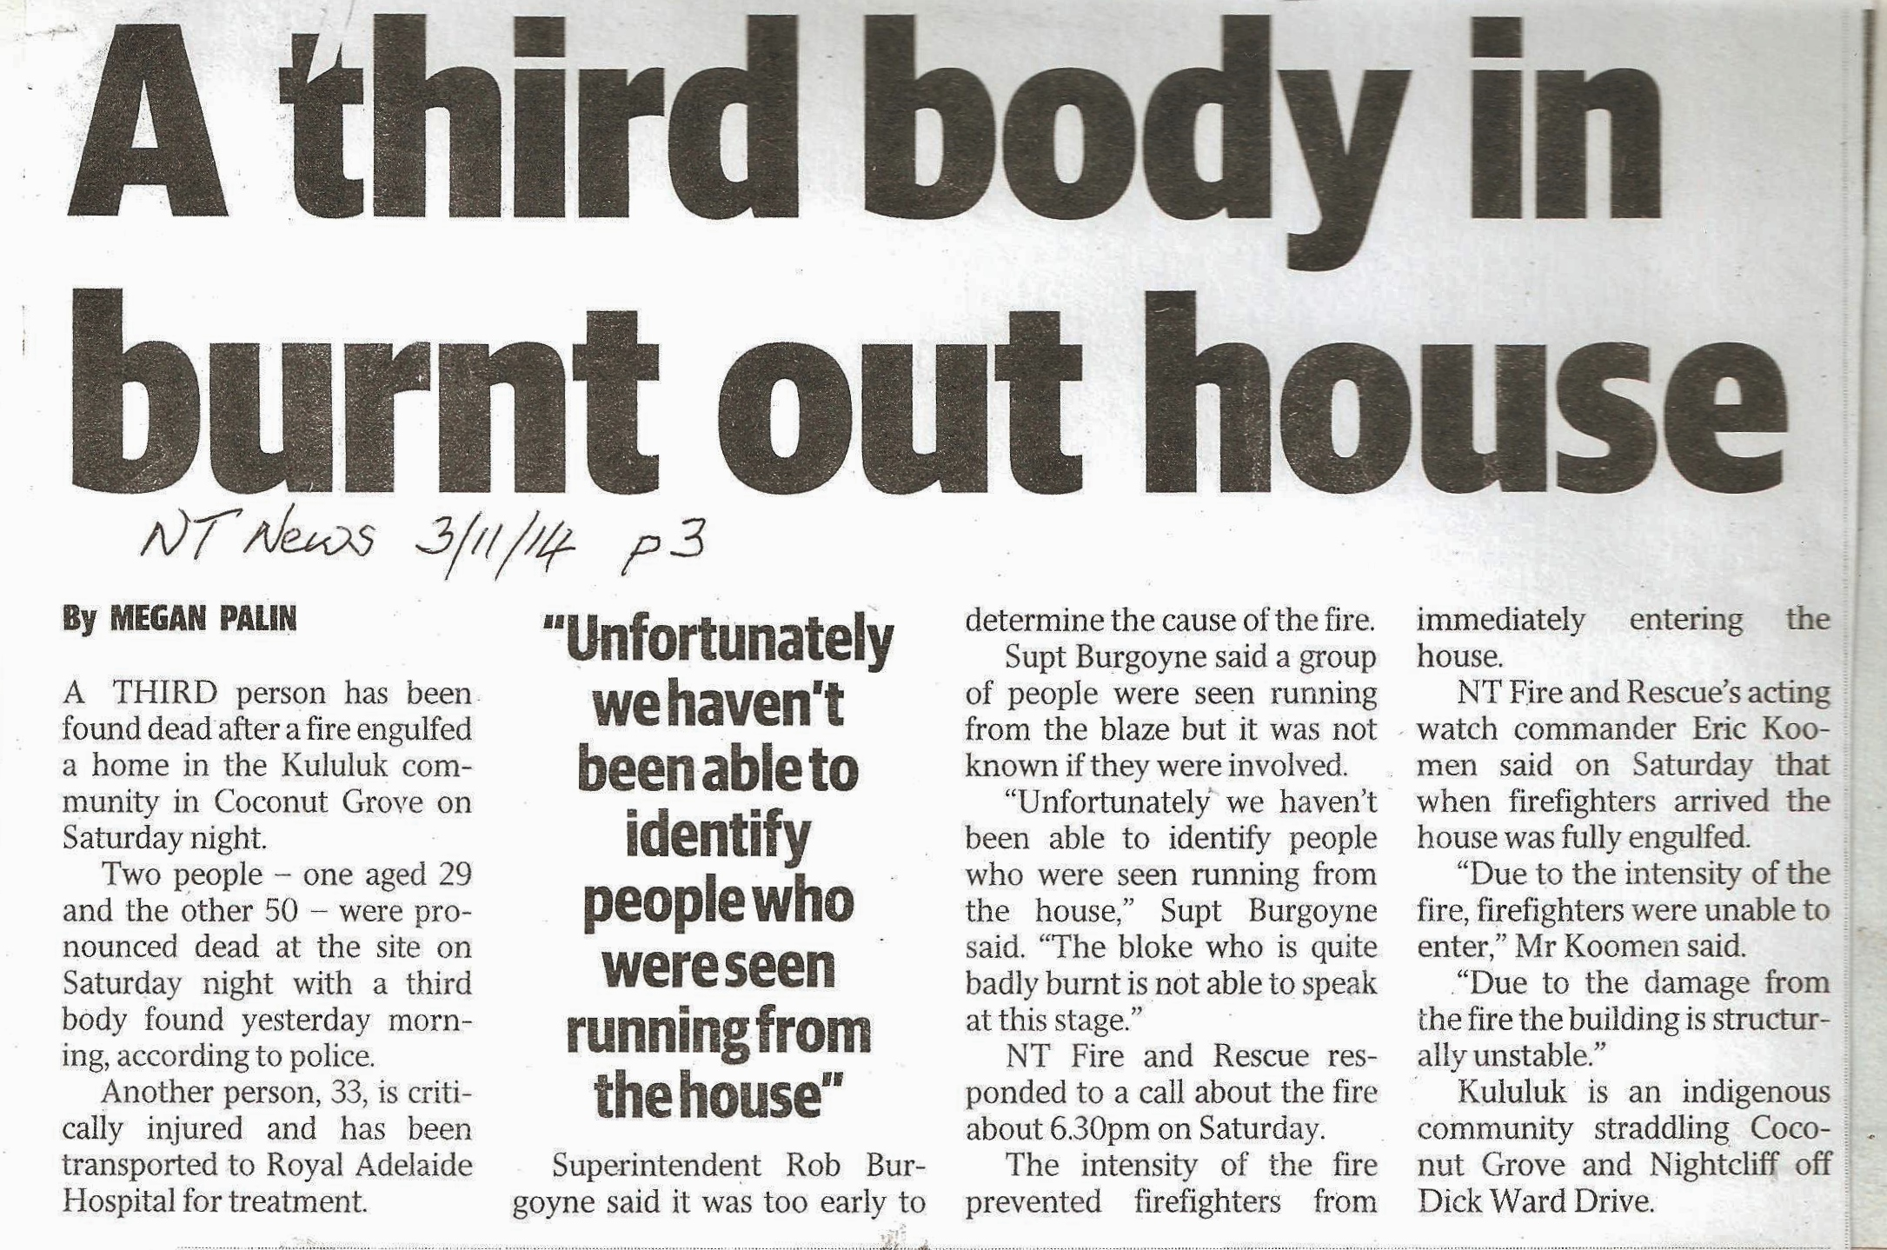
Isn't it time there was a coroner's report on the fatal Kulaluk house fire? It was almost one year ago now.
These are the facts we do know:
1. Jape's Citiland company has made a secret deal with the Kulaluk leaseholders to expand the Jape family's business empire onto 301 hextares of Aboriginal land in the heart of Darwin, won in the land rights struggle of the 1970s.
2. Jape is also expanding their business empire onto indigenous land in East Timor.
3. Jape is amongst the biggest fireworks dealers in Darwin.
4. Kulaluk had a plentiful supply of fireworks for months after the July 1 cut-off date.
We need to know what caused the fire and if there were smoke detectors in the houses.

