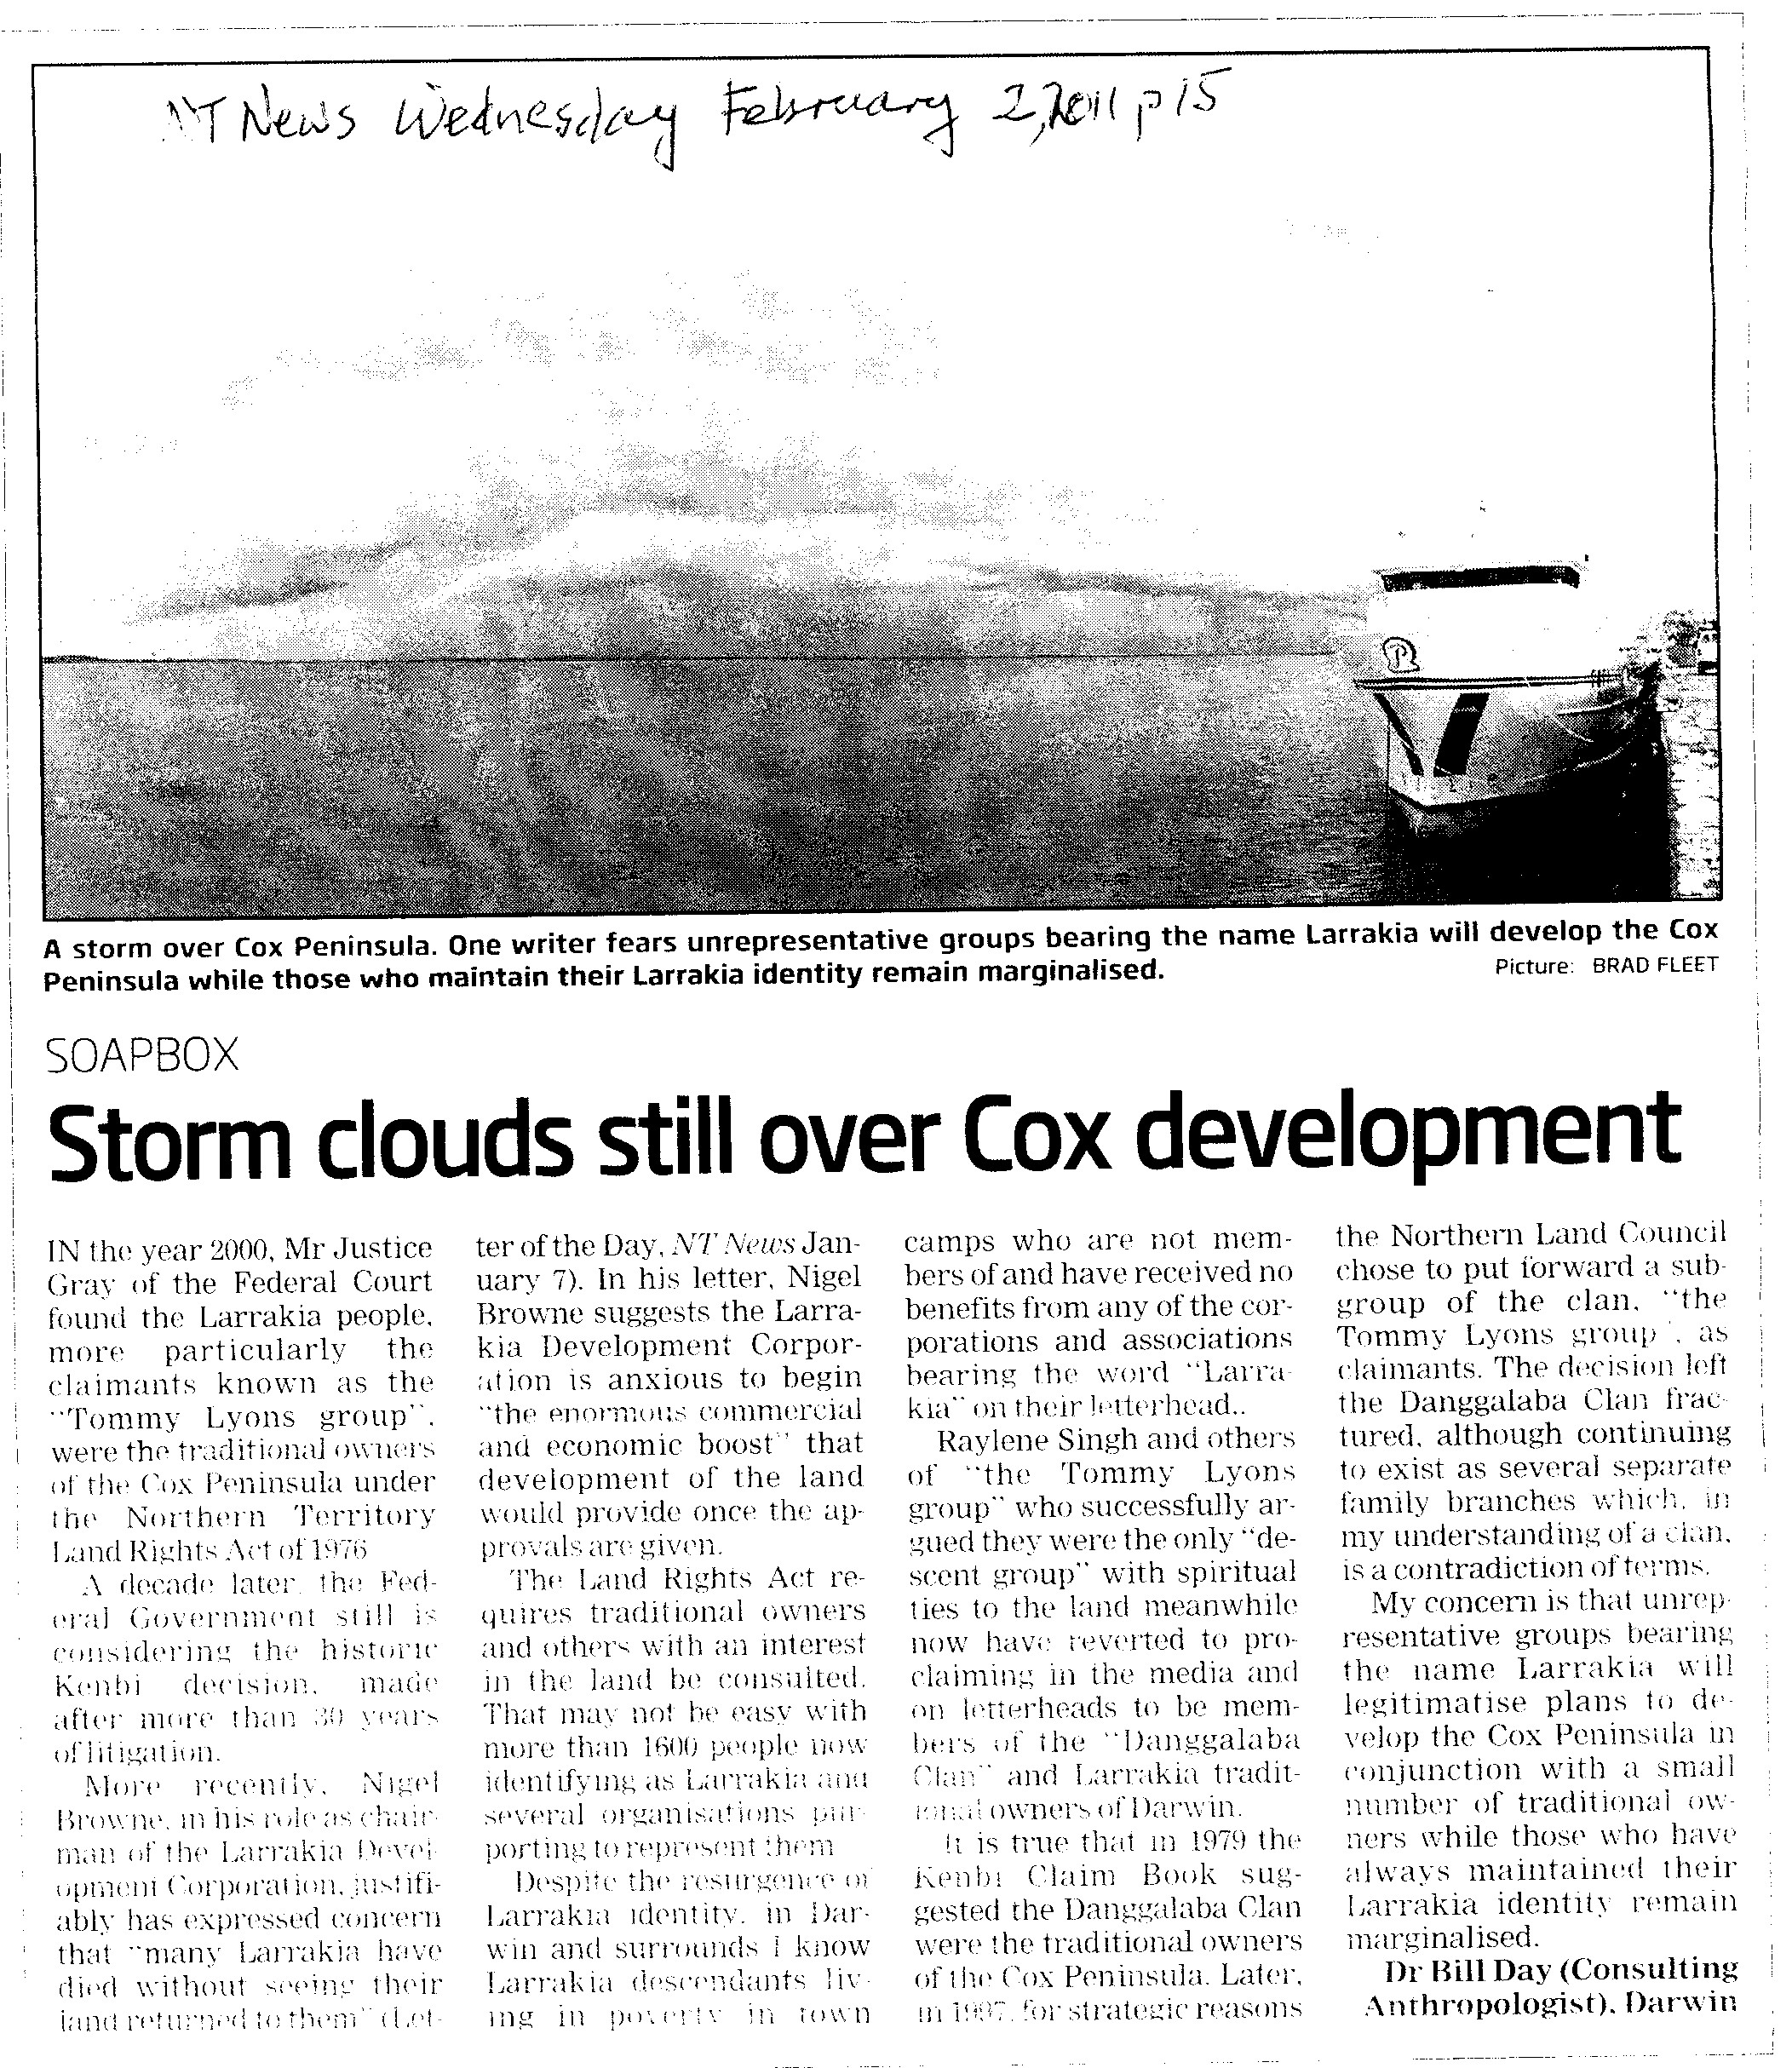

Above: letter published in Northern Territory News, Wednesday, February 2nd, 2011, page 15.

